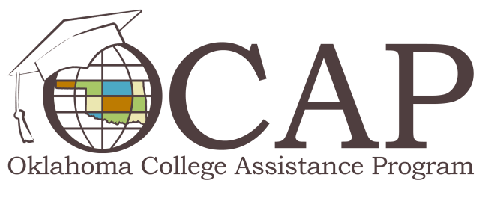

Student Loan Terminology Electronic Flyer

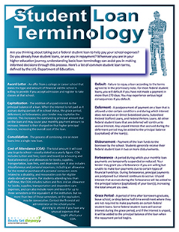
Throughout your higher education journey, you’ll have many decisions to make regarding student loans. Whether you’re deciding if you need to borrow, how much to borrow or which repayment plan to choose, it's important you're equipped with timely information every step of the way.
As a borrower, understanding basic student loan terminology is invaluable. For example, do you know the difference between a “subsidized loan” and an “unsubsidized loan”? Understanding the difference between the two could impact your decision to accept one or both types of loans, as well as how you choose to repay your loans.
To help you make those important decisions, you may want to download the Student Loan Terminology electronic flyer, developed by Ready Set Repay. It defines 20 basic student loan terms used by the U.S. Department of Education. A black and white version is also available. For more information and tools to assist you in your student loan repayment, visit ReadySetRepay.org.

