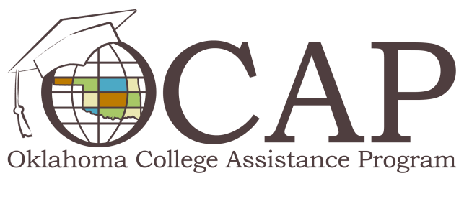

There’s Hope after Loan Default

Are you trying to get out of default? Do you want to continue your education? Loan rehabilitation is one option that can bring your federal student loans out of default, reinstate Title IV aid eligibility, and remove negative credit report ratings. To qualify for loan rehabilitation, you must:
- Make nine full, monthly payments during a period of 10 consecutive months. Payments must be:
  - Voluntary direct borrower payments (payments from state or federal tax refunds, trustee payments or wage garnishment are not considered voluntary).
  - Made on-time within 20 days of the due date.
- Complete and return a Rehabilitation Application to your servicer before the servicer receives the ninth consecutive payment (contact your servicer to request an application).
You may not:
- Make a lump sum pre-payment.
- Miss two or more monthly payments during the nine-month cycle.
Once you’ve made the nine on-time payments in 10 consecutive months and sent in your completed application, your account will be sent to a lender who’ll purchase the loan. This will bring your loan out of default and remove negative credit report ratings. You must maintain your payments until the loan rehabilitation is completed and you’re contacted by your new lender. It’s important to note that loan rehabilitation is only available to you once. For more information about loan rehabilitation and other options to help you get out of default, visit ReadySetRepay.org.

