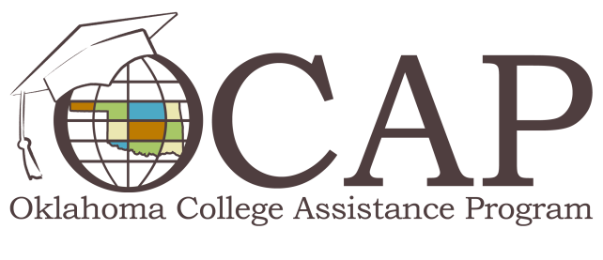

Six Tips to Make Students Career Fair Pros
Career fairs are a great opportunity for you to practice your people skills while meeting, and hopefully impressing, recruiters from a variety of companies. In a crowd of potential candidates, it takes more than good luck and a winning smile to stand out. Below are some key strategies that will help you make a good impression in a short amount of time.
- Research for results. It's a rookie mistake to walk into a career fair without first knowing who'll be there. Check the fair's website or call the coordinator to request a list of participating employers. Map out who you'd like to talk to and do some investigating. At minimum, explore their website and social media profiles to learn more about the mission and key services of each company.
- Come prepared. Bring multiple copies of your resume; one for each company you're interested in and a few extra, just in case. Carry them in a professional portfolio to keep your papers neat and easily accessible, and for a polished appearance.
- Dress the part. Your resume may be impeccable, but you won't be taken seriously if you look unprofessional. First impressions are often based on outward appearance, and while some recruiters may overlook outrageous style, it's best to dress conservatively when attending a career fair. Choose a professional outfit that's clean, ironed and fits appropriately.
- Prep your elevator speech. An elevator speech is basically a quick (two minutes or less) "commercial" highlighting the qualities and strengths that make you an ideal job candidate. Focus on what's in it for the employer and include information about your general background and some key statements that demonstrate your talents and leadership abilities. Once you're happy with your speech, write it down and practice it until you can say it with confidence and without hesitation.
- Ask the right questions. Show you're a serious candidate by asking educated questions. For example, asking "What type of training and professional development programs do you offer?" shows that you're eager to learn and want to keep your skills up-to-date. Avoid asking about salary or anything that could be easily discovered by browsing the company's website.
- Follow up. Many students never follow up after attending a career fair. It's good practice to send a hand written letter or email thanking the recruiter for the time and re-emphasizing your interest in the company. A professional thank-you message can leave a lasting impression.

