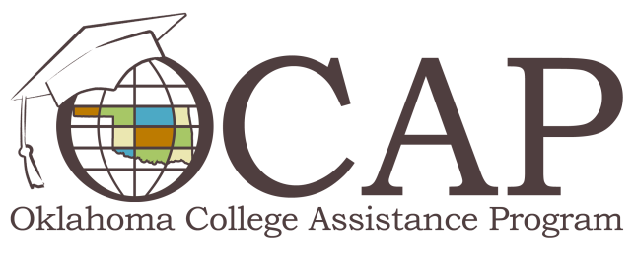

Present Yourself Professionally Online
First impressions can be formed within seconds of an introduction. When our first encounter is on the Web, through social media or other networking sites, we lose a great deal of the personal interaction that helps us form opinions of our peers. Safeguarding and maintaining your image online will help ensure you're putting your best foot forward in a professional capacity from the start. Use the following tips to ensure you're as polished online as you are in person.
Plan Your Profiles
Social media can play a huge role in your professional image. Determine which social media platforms you'd like to use professionally, like LinkedIn or Twitter, and set up your profiles accordingly. Remember to monitor your online presence regularly, including your personal social media accounts; linked posts from peers include content you can't control. Most social media sites have customizable filters and privacy settings that can help you protect yourself and your image. Privacy settings are not foolproof, however, so be aware that anything you post – or that someone you're connected to posts - has the potential to become public. It's best to do all you can to maintain a professional image in all of your social media accounts.
Pose for a Portrait
Professional business portraits can be an important tool in introducing yourself to potential employers, clients, partners or students. You may be asked for your photo in many professional situations, including conference materials, industry interviews or online profiles. Suit up and find a photographer who will take a quality headshot for a reasonable price. This is a great opportunity to put your best-dressed foot forward, so remember to post the photo on your social media profiles.
Perfect Your Bio
Your professional biography is another essential piece of your reputation toolbox. According to BrandYourself.com, a well-written bio can serve a variety of purposes. Most experts say you should write two or three different biographies ranging from 100 to 250 words. Your biography will serve as a shortened version of your resume, informing readers of your professional background. You'll want to include your education, years of experience and any major accomplishments. Keep it brief and stick to facts that are professionally relevant; while it's acceptable to portray your personality through your writing style, your professional peers are more likely to be interested in your credentials than your personal life or hobbies. Be sure to include highlights from your bio on your social media profiles.

